**School Workforce Census common issues**

Please note – screen shots shown in this guidance are for SIMS users only. If you require assistance for a different MIS, please contact you support provider.

**Personal Details**

**Disability and Ethnicity not collected**

These data items are statutory and the DfE expects schools to return this information for the vast majority of staff. For the first time in 2025, missing information will generate an error message both in School’s MIS and COLLECT.

We continue to receive returns from schools with large numbers of staff members recorded with ‘Not Yet Obtained’ for both data items.

In SIMS, they can be entered onto the personal details in tab 2: Personal Information

**Missing Teacher Number**

Large numbers of Teachers are recorded with no Teacher Number –

* Teacher is from Overseas
* Agency staff
* QTLS or EYTS status (numbers are not 7 digits and should not be entered)
* Schools Direct or other Trainee teacher

This is acceptable with an explanation for the DfE, but in the case of Overseas teachers, the DfE expect to be told the country the person has qualified in and also they require the teacher number the person acquired in their home country. Teacher numbers for staff with QTLS or EYTS must be added to the explanatory note for the DfE on COLLECT.

Some trainee teachers may be paying towards the teacher’s pension scheme. If this is the case, they may have been allocated a Teacher Number and their pension paperwork should show what it is. In this instance the number should be added to their records in you MIS and submitted on your return as normal.

**Professional Details**

**QTS Route missing**

The DfE guidance for the school census says that the DfE want to know how teachers have qualified. To do this, all schools are required to complete the ‘QTS Route’ details for all teachers who have started their first teaching post.

The information can be recorded here in SIMS

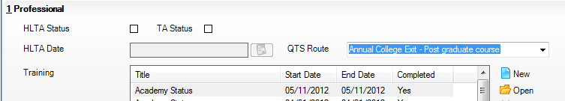

Please note that the DfE also require this field to be completed for Overseas trained staff. The two options to choose from would be

* ‘Overseas Trained Teacher Programme’ for those staff who have worked towards or are training towards UK QTS
* ‘Overseas trained Teacher, not yet on Programme’ for those staff who are not training towards UK QTS

**Qualifications Missing**

For all **teachers**, the following information is required:

* their **initial teacher training qualification** eg PGCE, BEd, Certificate in Education
* for those with a PGCE, information on **prior degrees**
* for those without QTS or those trained overseas, **all qualifications relevant to their engagement as a teacher**
* any **subsequent qualifications** gained relevant to their job as a teacher

Colleagues must check with the Teaching Regulation Agency to see if their Teachers qualifications have been recorded before census day. If the teacher’s qualifications are on the TRA database they do not need to be recorded on the census. If they are not on the database then all details must be recorded on the census.

Instructions on how to use the website and how to register for the service are available here -

[Teaching Regulation Agency (education.gov.uk)](https://teacherservices.education.gov.uk/)

Please contact the Teaching Regulation Agency in good time as it may take several working days to register for the service

For **non-teaching school leaders**, information about their degree or about any other qualifications listed below should be provided.

Qualifications in England, Wales and Northern Ireland are grouped into levels from entry level to level 8. The following qualifications, which are graded at level 4 or above (that is, those higher than A-level) should be included.

* Post-graduate Certificate in Education (PGCE)
* BEd or other first degree combined with teacher qualifications
* Certificate in Education or equivalent
* Doctorate, for example PhD
* Master’s Degree, for example MSc, MEd – **also SENCO qualification**
* Postgraduate certificates and diplomas
* Other first degree (that is degrees other than BEd or other first degree combined with teacher qualifications) such as BA and BSc
* Graduate certificates and diplomas
* Diplomas of higher education and further education
* Foundation degrees
* Higher national diplomas
* Certificates of higher education
* Non-UK teaching qualification

**Class of Degree Missing**

This information is required if any teachers have an arrival date in school after 1st August 2013 and their qualifications are recorded as ‘First Degree’ or ‘Bachelor of Education’. Please cross check the Contracts report against the Qualifications report to ensure that every teacher with an arrival date after 1st August 2013 has their class of degree recorded.

**Employment Details**

**Incorrect Weeks per year**

This data item records the number of weeks per year for which a member of staff is paid, **including any paid holiday**. Therefore, if a member of staff works on a term-time only contract they would work for 38 or 39 weeks per year but also be paid some annual leave entitlement. The ‘Weeks per year’ recorded on the census must reflect how many weeks the member of staff is actually paid for. As the person’s base pay is calculated using this information a large number of people are recorded every year as being paid below the minimum amount for their pay range.

A large number of Support Staff were also recorded as working/paid for 52 weeks a year when they were actually term-time only. Again, their base pay was incorrectly calculated and they were recorded as being paid a significantly higher amount than they should be.

This information can be found on the contract / Service Agreement details report in SIMS and entered onto the staff members contract as shown below

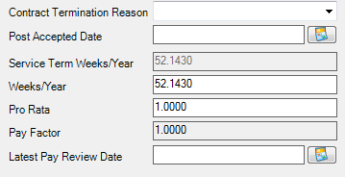

**Zero Hour / Casual Contracts**

The DfE are only interested in information for members of staff who work regular hours for a minimum of 28 days or 4 weeks continuously, for example a midday supervisor who works for two lunchtimes a week, every week for at least a month. A supply teacher who works odd days when someone is off sick who happens to work for 28 days spread over the course of the academic year is not to be included on the census as they are not regular hours.

There are two ways to ensure that casual contracts are not included on the census.

If a member of staff only has a casual contract and they do no other work at your school you can prevent the census from picking up their details by removing the ‘eligible for SWR’ tick from their Personal Details

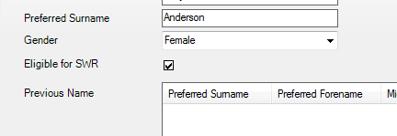

If the member of staff has more than one contract (e.g. TA and also covers midday supervisor if someone is off sick), the casual contract is prevented from being collected if the role ‘Do not include in Statutory Returns’ is selected

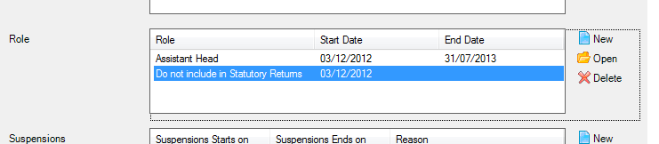

Simply click on ‘New’, and then select this option from the drop-down list.

This method can also be used to remove contracts for extended services staff (breakfast and after-school clubs) from the returns as these are also not in scope.

**Incorrect Base pay**

A large number of staff were reported with incorrect base pay information last year as the pay ranges had not been updated correctly.

If you receive a PN41 form from the LA, please ensure that the base pay information in your census matches the figures shown on the form. This can be done by looking through the Payment Details report.

Bucks Pay staff on range 1 (A or B) were also recorded at a large number of schools as being paid below the minimum wage as the ranges had not been updated correctly for the beginning of the year. Please ensure that the range selected is either 1, 1A or 1B, range ‘1A and 1B’ does not exist anymore and has not been I use for several years.

**Missing Contracts**

It is possible for staff member’s personal records to be on the census without any contract information being collected. This does not generate an error on school’s MIS or the DfE COLLECT system but affected staff will be identified by a report the DfE produce.

There were several staff affected with this issue last year for the following reasons –

* New member of staff who started at the beginning of September but the contract had not been entered onto the MIS by census day in November
* Agency staff who had not been recorded with a Service Agreement
* School Governors / Volunteers where the ‘eligible for SWR’ tick had not been removed
* Casual staff with no contract recorded
* Staff who had left before the start of the previous academic year but no end date had been entered onto their contract or in their Employment Dates (Employment Details, fourth row down)
* Role recorded as ‘do not include in statutory returns’ in error
* Member of staff was supposed to start but didn’t arrive
* End date added to the role on a current contract in SIMS

Any schools affected by this issue this year will be asked to send a new return to rectify the problem(s).

An easy way to identify if there are any staff members affected is to compare the ‘Staff Basic Details’ report against the ‘Contract/Service Agreement Details’ report. Anyone on the Basic details report should also have a contract or service agreement recorded. If they don't you need to check their contract and personal details to work out why.