**Exercise 3**

**Contextual Safeguarding**

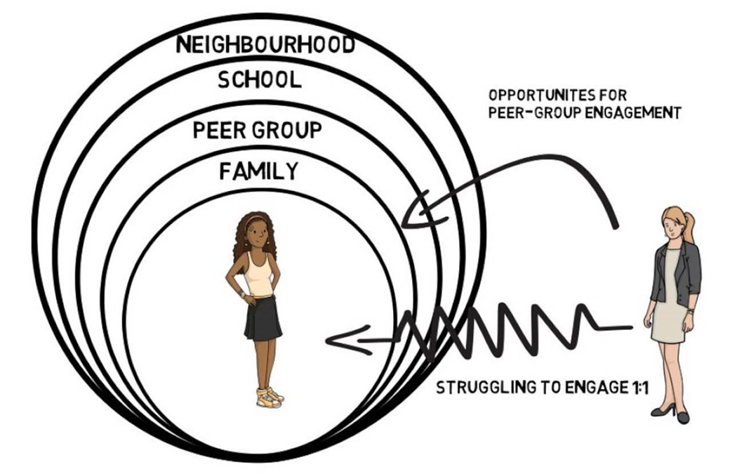

**Carlene Firmin – Bedfordshire Uni**

**POSITIVE AND NEGATIVE RELATIONSHIPS**

**Introduction and Facilitators Notes**

The exercises in this section look at developing good relationships and improving

self-esteem, as these are vital elements to ensure young people develop healthy

relationships in the future. **Research has shown that low self-esteem is a major**

**factor in young people becoming vulnerable to sexual exploitation by**

**abusive adults.** These exercises serve as an introduction to the more sensitive

areas of sexual exploitation work, and are a ‘way in’ to look at positive

relationships. Young people are encouraged to recognise that they can have some

control within their relationships, and are helped to consider strategies to deal with

negative aspects of relationships*.* The exercises do not need to be undertaken in

any particular order and could be used as a programme over a period of weeks

depending on time available.

**The Relationship Grid (20 minutes)** Introduces the subject of ‘relationships’ and

explores the different types of relationships young people have e.g. family, friends,

boy/girlfriends, etc. They are asked to ‘score’ these relationships on a grid to show

who is close to them and who is less so. There is then an opportunity to look at

good and bad aspects of these relationships and this should lead to some

discussion about how they ‘manage’ relationships and the skills they have

developed/could develop to help them do this, e.g. compromise, taking control, etc.

**Happy Ever After (20 minutes)** helps young people to decide what aspects they

want within their own relationships and which ones they don’t – it empowers them

to control what happens in their relationships. This follows on well from the

**Relationship Grid** exercise, and so could be used together for a 35/40 minute

session.

**“A Good Friend is…”/“A Good Partner is…” (30 minutes)** exercise enables

young people to begin thinking about what they look for in an ideal relationship. It

may be helpful to use the “A good friend is…” with KS3 pupils and “A good partner

is…” in KS4. This is a popular exercise with young people and encourages them

to consider and talk about the quality of their own relationships.

**It’s My Life! (20 minutes)** asks young people to consider ‘big’ life questions and

discuss them in groups – it will help them to see other viewpoints as well as think

about how these questions affect them personally.

**POSITIVE AND NEGATIVE RELATIONSHIPS**

**THE RELATIONSHIP GRID**

**AIM:** To introduce the subject of ‘relationships’ and to begin

exploring the types of relationships young people have and

how they feel those people feature in their lives.

**LEARNING** Young people will be able to identify who is important in their

**OUTCOMES:** lives and understand the different kinds of relationships they

have, and begin to look at the positive and negative aspects of

those relationships.

**YOU WILL NEED: Relationship Grid** worksheets and the **example Grid.**

**TIME:** 15 minutes

**OUTLINE:** Ask the whole group to ‘thought shower’ the people they feel

they have relationships with. This will help them to understand

the different types of relationships they are involved in and

compare them, e.g. the relationship they have with a teacher

may not feel the same as the one they have with a

parent/carer.

Give each young person a copy of the **Relationship Grid.** The

grid is split into five sections to represent different aspects of

their lives – e.g. home, peer group, school, wider family etc.

The circles radiating out of the centre represent how close

they feel to a person. They should put **themselves in the**

**centre of the grid** and then place the people they have

relationships with in the relevant sections. They may not need

to use all five sections. The closer they place people to

themselves on the grid the more important that relationship is

to them. (See example).

Ask for volunteers to talk about their grid – why are some

people closer than others, are they all good relationships?

What aspects of those relationships are not so good (e.g.

parents may be close but want to control aspects of their lives

- this should lead to a general discussion).

Make the point that no relationships are ideal but that they are

already using skills such as compromise, taking control,

resolving conflict etc., to make them work better. Take

examples from the group and ask them to suggest ways to

improve relationships.

**RELATIONSHIP GRID**

Friends

Home

Others

School