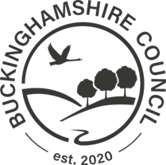

Sponsorship cost approval for schools

- £525.00 CoS application fee (non-refundable)
- £1,320.00 per year of sponsorship (min 1 year max 5 years)
- £42 per application – BC application fee (non-refundable) + £21 monthly admin charge for the duration of sponsorship.

Name of the overseas job applicant: |  | Cost centre:
 | Full name |  | e.g. 12345

Agreed year(s) of sponsorship and total: If the applicant is currently on student visa:
1 year - £2,139.00 ☐ (Tick this box) 1 year - £819.00 ☐ (Tick this box)
2 years - £3,711.00 ☐ (Tick this box) 2 years - £1,071.00 ☐ (Tick this box)
3 years - £5,283.00 ☐ (Tick this box) 3 years - £1,323.00 ☐ (Tick this box)
4 years - £6,855.00 ☐ (Tick this box) 4 years - £1,575.00 ☐ (Tick this box)
5 years - £8,427.00 ☐ (Tick this box) 5 years - £1,827.00 ☐ (Tick this box)
Authorisation by Head Teacher:

Full name: |  |  | Date of signature
 | Full name |  |  | MM |  | DD |  | YYYY

Signature:

